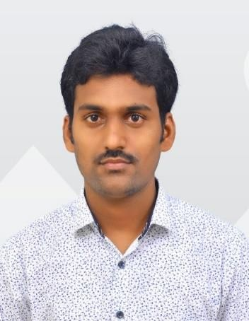

**Profile Summary**

B-Tech in Mechanical Engineering with a CGPA of 7.0 along with some basic Auto CAD skills. Strongly desired to excel in technical profession.

**Contact:**

+91 9505567373

[santharao6001@gmail.com](mailto:santharao6001@gmail.com)

[LinkedIn- santharao](https://www.linkedin.com/in/santharao-jinaga-44a113235/)

[GitHub-santharao](https://github.com/santharao6001/Java_Practice)

**Achievements:**

* Won first place in “Quiz” Competition at the school level.
* Attended Hybrid Vehicle workshop.
* Project on Mini wood Turning lathe machine.
* **Interests:**
* Following to develop Interpersonal skills
* Searching new Coding Languages in

Software

**Languages Known**

* Telugu
* English

SANTHA RAO JINAGA

# Key Skills

Python

Basics of Java

Auto Cad

Microsoft Office

Word

**Projects**

**Title: Concentration Solar Thermoelectric Generator**

**Description:** Photovoltaic is one method of converting

solar light in electricity and companied with thermal system will producing heat and electricity at the same time. This energy used to produce Electricity That can used for irrigation purpose.

Technology:

photovoltaic technology and thermoelectric technology.

# Education

B-Tech: Mechanical with 7.0 CGPA - 2021

Sri Venkateswara College of Engineering and Technology.

Etcherla, Srikakulam.

DIPLOMA: Mechanical with 64.53 Percentage - 2017

Aditya Institute of Technology and Management, tekkali.

SSC with 7.0 CGPA – 2014

Sri Chaitanya Techno School, palasa

.

# Certifications

bitLabs Associate Full-stack developer program